From Low-Quality Leads to Ideal Cases: SEO for a Virginia PI Firm

SEO

Results that speak for themselves

Key Stats & Results


2x Organic search traffic — more than doubled

65+ Web pages ranking on page 1 of Google

Behind the transformation

Virginia Personal Injury Firm Doubled Traffic and Improved Lead Quality
A Virginia personal injury law firm partnered with Rankings.io to transform its website into a high-performing client acquisition engine in one of the most competitive legal markets in the country. Through a combined strategy of technical SEO, targeted content development, and conversion-focused website improvements, the firm more than doubled its organic search traffic and achieved 65+ first-page rankings for high-intent personal injury keywords. The result was not just more traffic, but significantly higher-quality leads and stronger cash flow driven by clients in the firm’s priority practice areas.

FROM CHALLANGES TO SUCCESS


The Challenge
When this Virginia personal injury firm partnered with Rankings.io, the problem wasn't a lack of ambition, it was a lack of the right infrastructure to compete in one of the country's most saturated legal markets.
Hundreds of firms fight for client attention across print, television, and digital channels simultaneously in Virginia's intensely competitive personal injury landscape. Standing out requires more than just advertising spend. It requires a website that can attract the right visitors organically, qualify them through content, and convert them efficiently.
The firm's website at the time fell short on all three fronts. It poorly defined the firm’s practice areas, which meant organic traffic, when it did arrive, often didn't match the cases the firm actually wanted to take. Lead quality was low, and the on-site experience wasn't set up to convert the visitors who did land.
The goal was clear: build a website that functioned as both a lead magnet and a high-performance conversion tool, one that would consistently attract clients in the firm's target practice areas — car accidents, product liability, medical malpractice, wrongful death, and negligence.
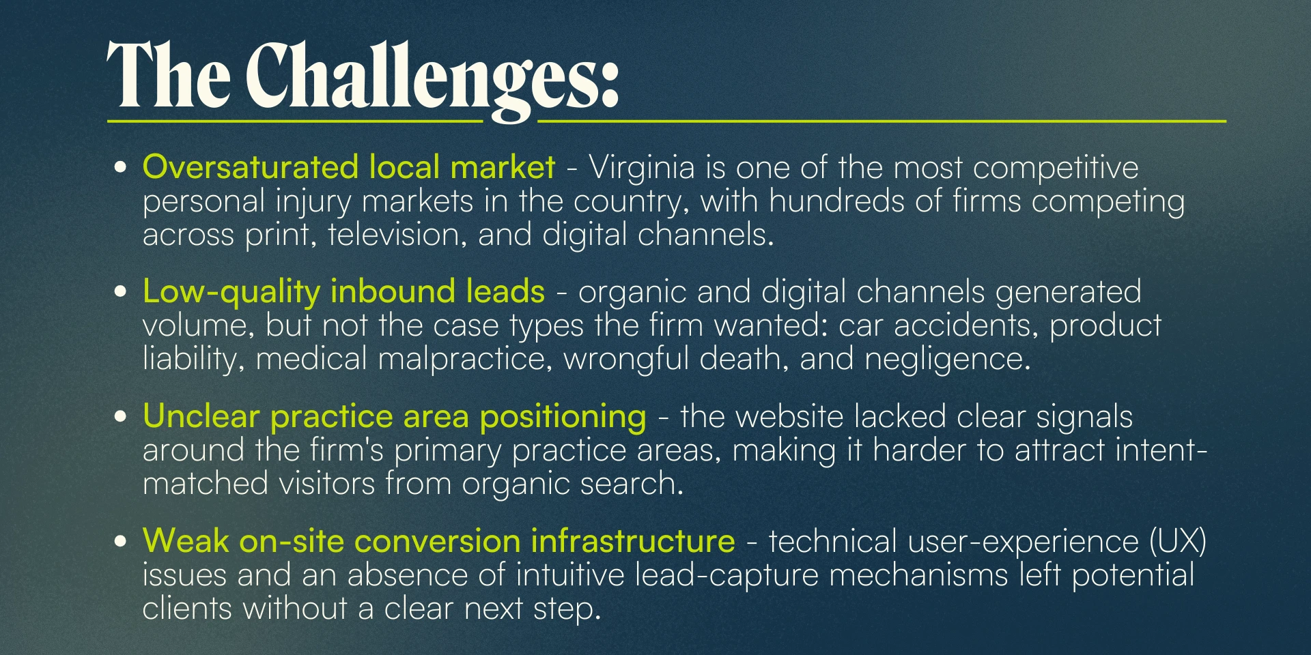



How We Did It: The Strategy
Rankings.io deployed a comprehensive SEO, content, and conversion strategy tailored to the realities of Virginia's competitive personal injury market. Rather than treating traffic and leads as separate problems, we designed every element of the engagement to improve both simultaneously.

SEO Strategy for a Virginia Personal Injury Law Firm
The approach combined technical remediation, targeted content authority, and local SEO execution, all tied together with ongoing reporting and a clear roadmap for continued growth.

1. Website Redesign & Technical UX Improvements
Rankings.io began by addressing the technical issues that undermined the firm's on-site user experience. A full website redesign corrected structural problems and introduced intuitive lead-capture forms optimized for the moments when potential clients are ready to make contact. The result was a 75% increase in on-site conversions.

2. Custom Content Strategy & Authority Publishing
Rankings.io developed a custom content strategy built around the firm's target practice areas and the specific queries Virginia personal injury clients use when searching for legal help. Content was published to Virginia's most prominent legal channels, including Virginia Lawyers Weekly, keeping the firm visible in its professional community and building the topical authority needed to rank for high-intent keywords.

3. Local SEO & Citation Building
A dedicated local SEO campaign ensured the firm appeared prominently across all relevant Virginia search results. This included building local citations, claiming and optimizing key local profiles, and establishing consistent NAP signals across the web, all working together to reinforce geographic relevance for the firm's target markets.

4. Link Building from Trusted Legal Sources
Rankings.io executed a targeted link-building campaign to earn backlinks from other trusted legal websites. These high-authority links strengthened the firm's domain authority and directly supported its ability to rank for competitive personal injury keywords at both the local and state levels.

5. Monthly Reporting & Ongoing Campaign Management
Throughout the engagement, Rankings.io delivered detailed monthly PDF reports covering campaign progress, keyword movement, and next steps, ensuring the firm's leadership stayed fully informed and strategically aligned at every stage of the partnership.



Before & After
After entering its third year of partnership with Rankings.io, the firm's results across organic visibility, lead quality, and on-site conversion completely transformed its digital performance.
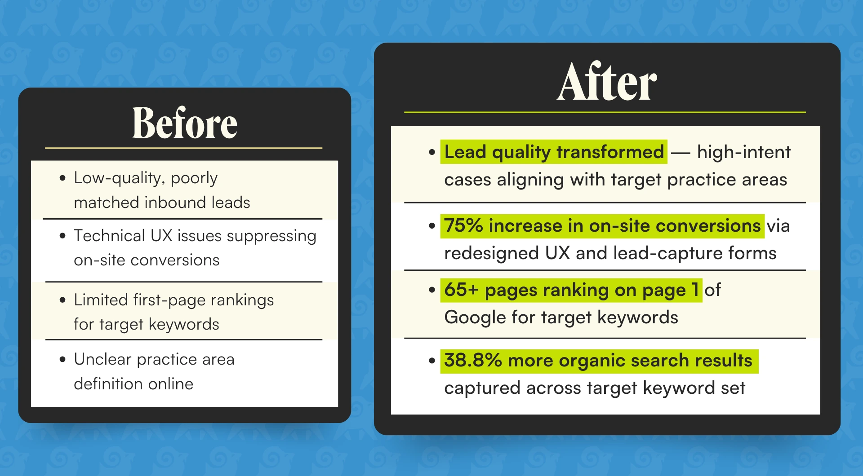
The firm's own assessment of the outcome: Lead quality before Rankings.io was low and poor. After engaging us, lead quality, and, in turn, cash flow, became consistently strong. The firm now attracts more of the cases it wants and converts more clients after just a single site visit.

Key Wins
- Organic search traffic more than doubled — the firm's most significant digital growth milestone
- 38.8% more organic search results captured across the target keyword set
- 65+ web pages ranking on the first page of Google for high-intent personal injury terms
- 75% increase in on-site conversions driven by UX redesign and optimized lead-capture forms
- Lead quality dramatically improved — the firm now consistently attracts clients in its priority practice areas: car accidents, product liability, medical malpractice, wrongful death, and negligence
- Cash flow improved alongside lead quality — converting more clients after a single visit to the site

Ready to Grow Your Firm?
This case study shows how the right combination of technical SEO, content strategy, and conversion optimization can transform both the volume and quality of leads for personal injury firms in the most competitive markets.
At Rankings.io, we specialize exclusively in SEO for lawyers. We understand what it takes to win visibility in saturated legal markets and to turn that visibility into the right cases.
More traffic is only part of the equation. We build strategies that attract your ideal clients and convert them.

